DIGITAL ASSIGNMENT-1

NAME: GADAMSETTY RISHITHA REG. NO: 20BIT0200

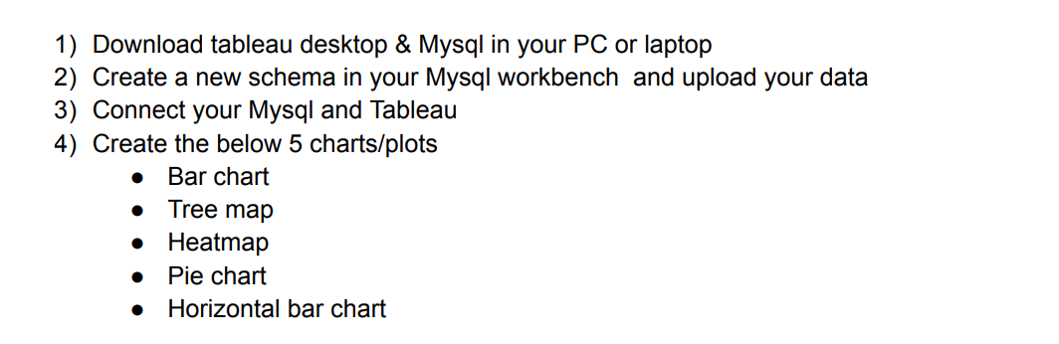

I have downloaded both tableau desktop and Mysql workbench in my PC.

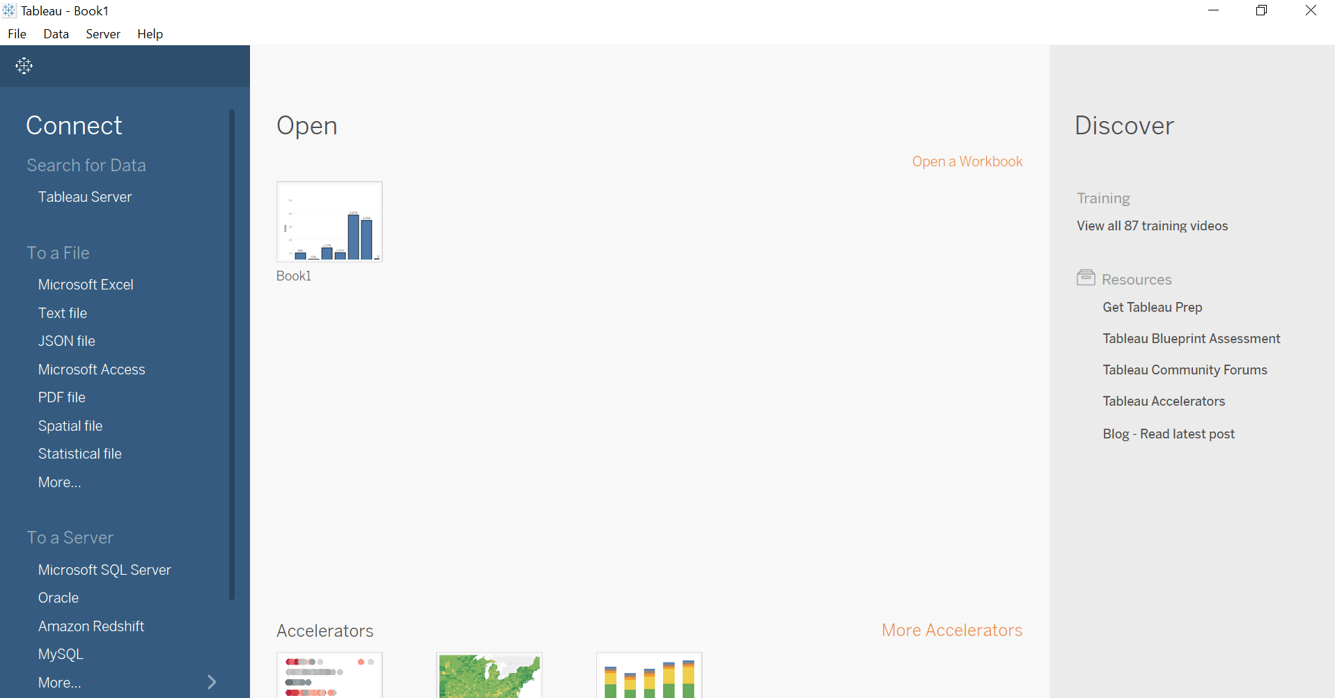



I will start with creating a new schema in my workbench and upload my data.

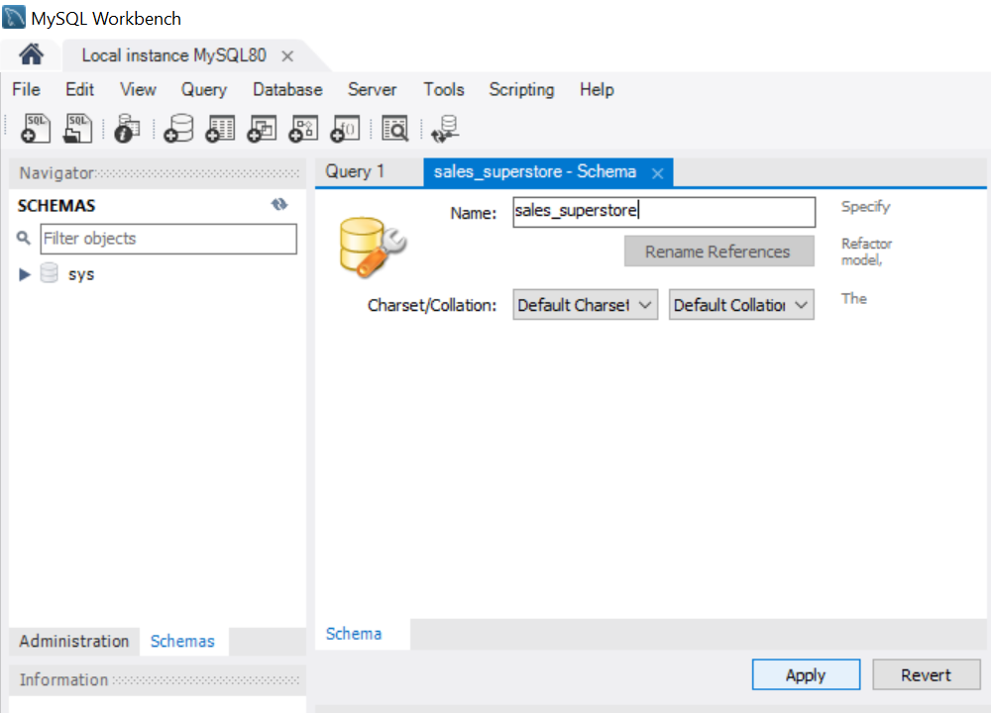

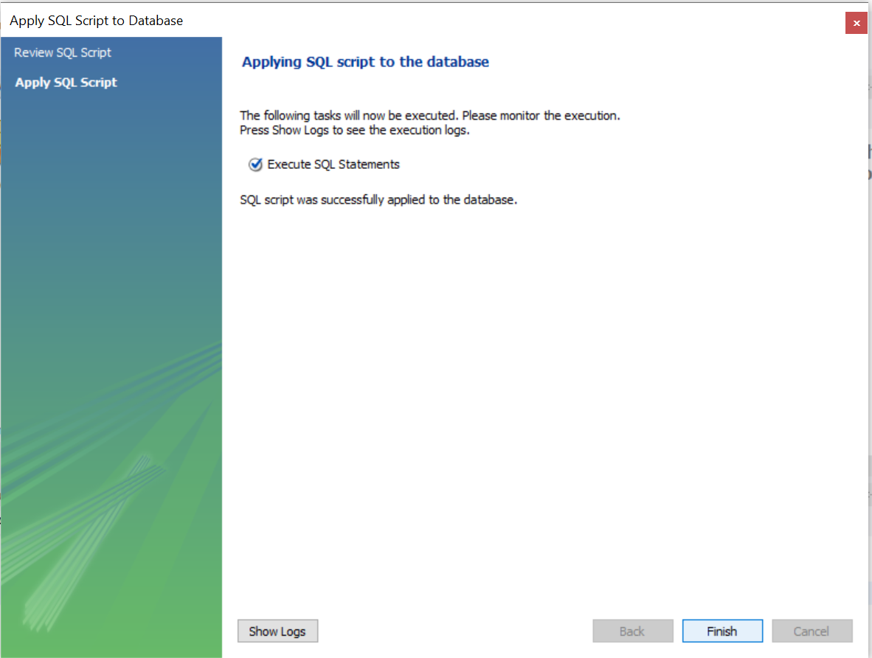

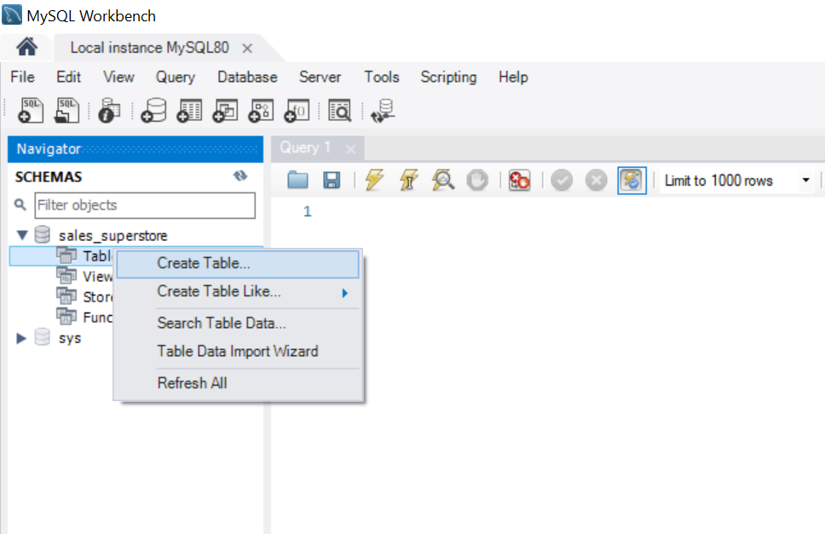

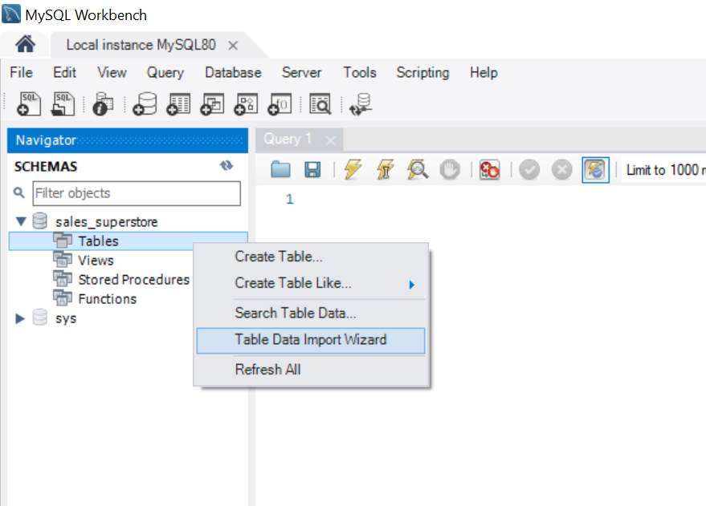

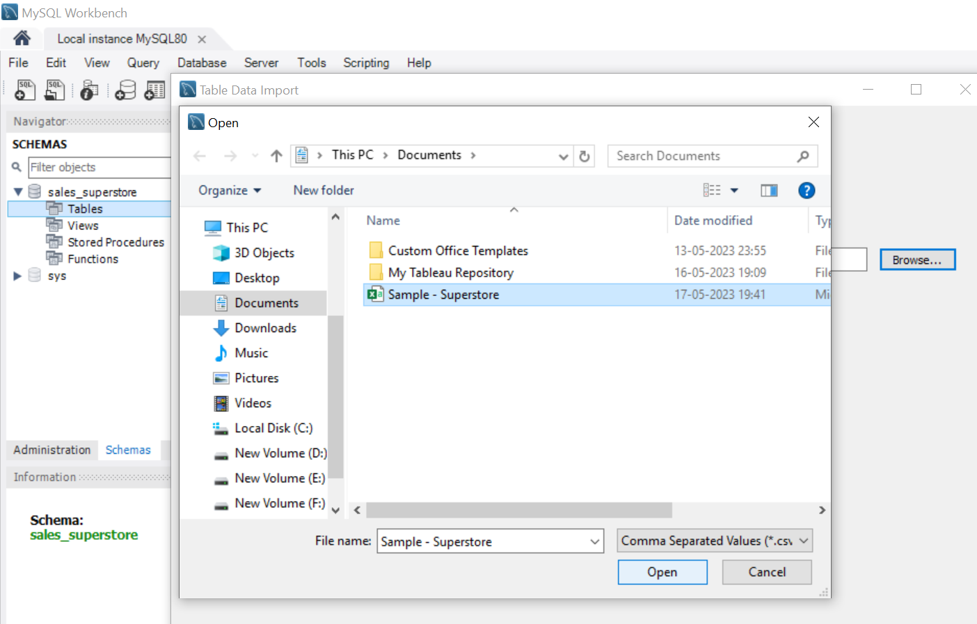

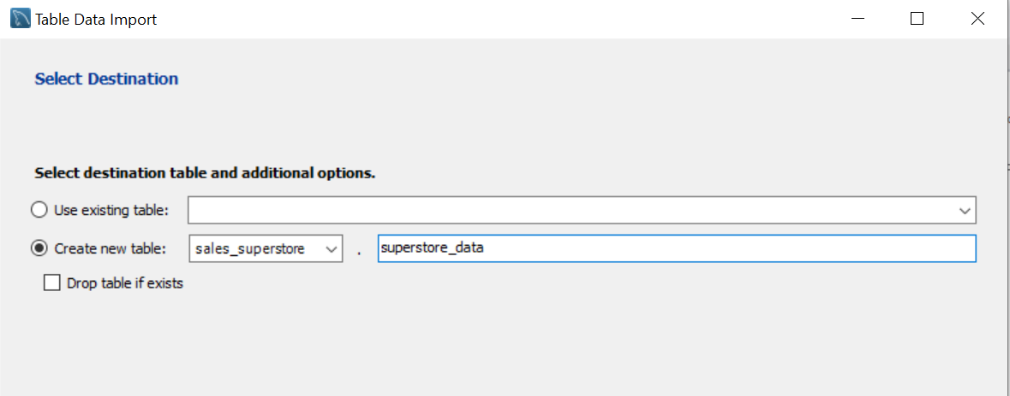

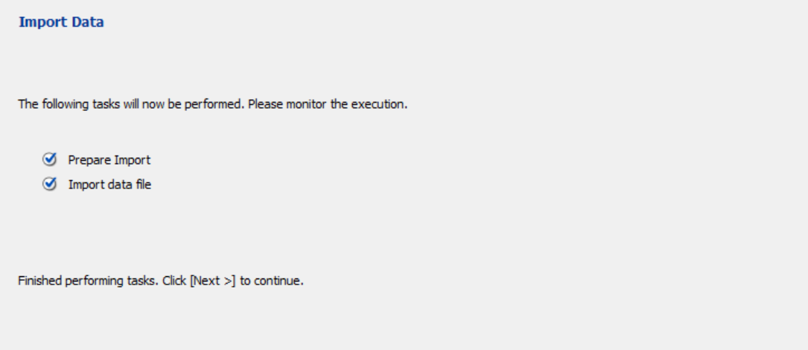

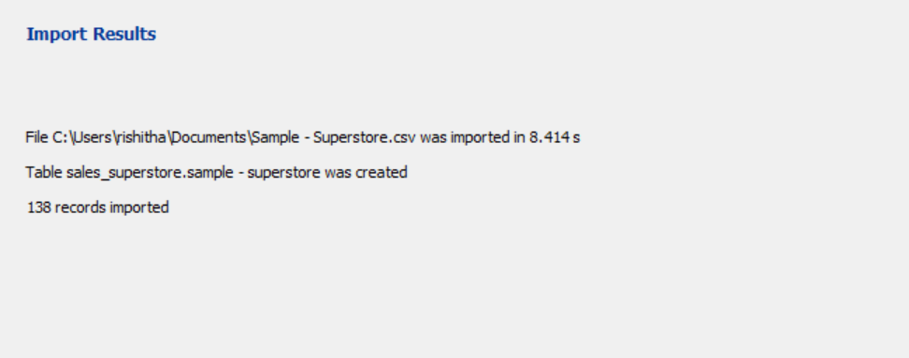

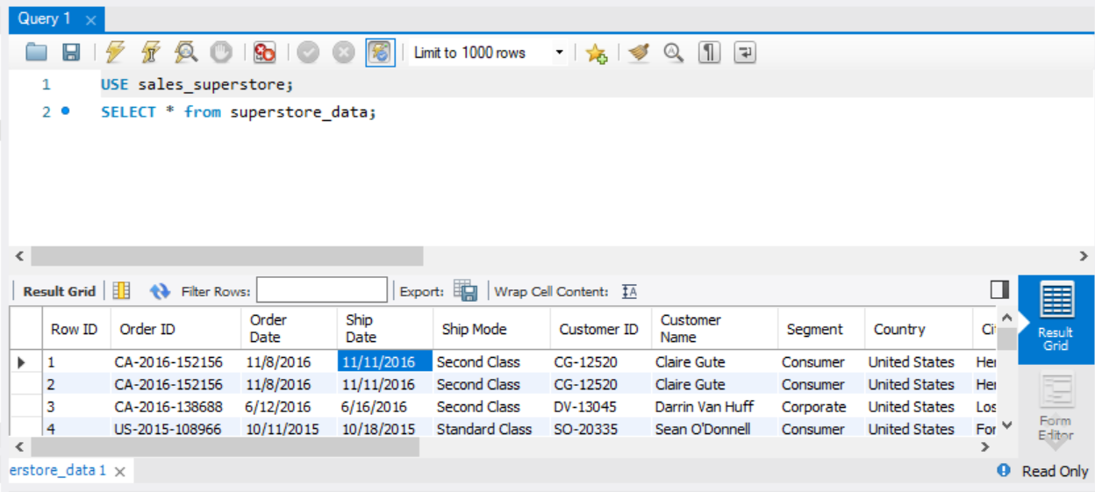

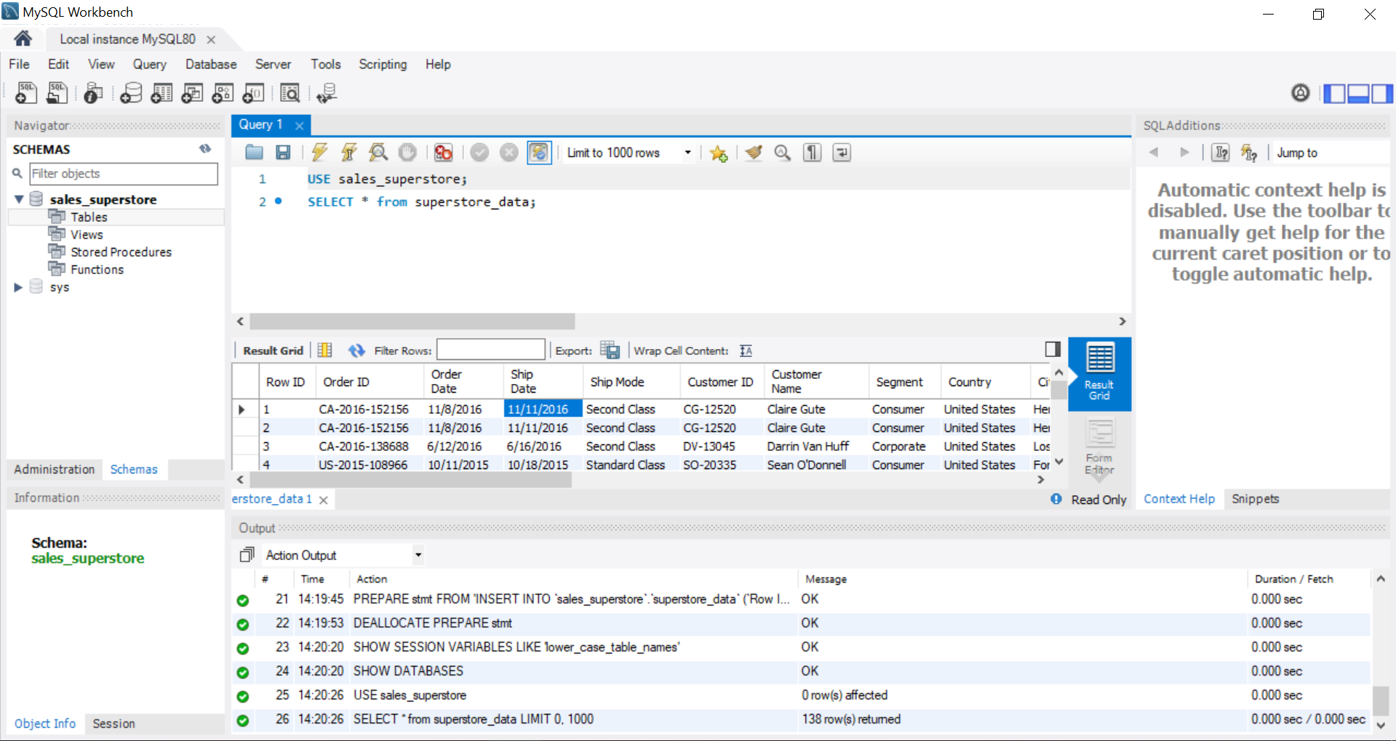

Now, I will connect Mysql and Tableau.

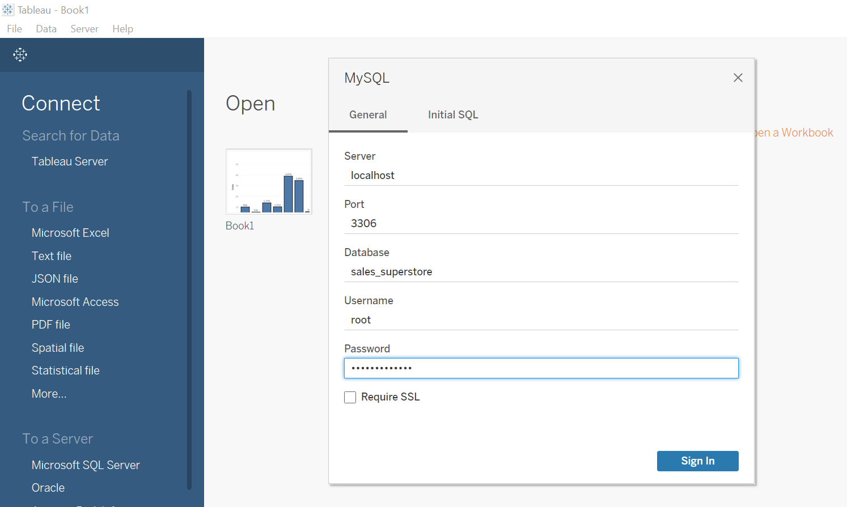

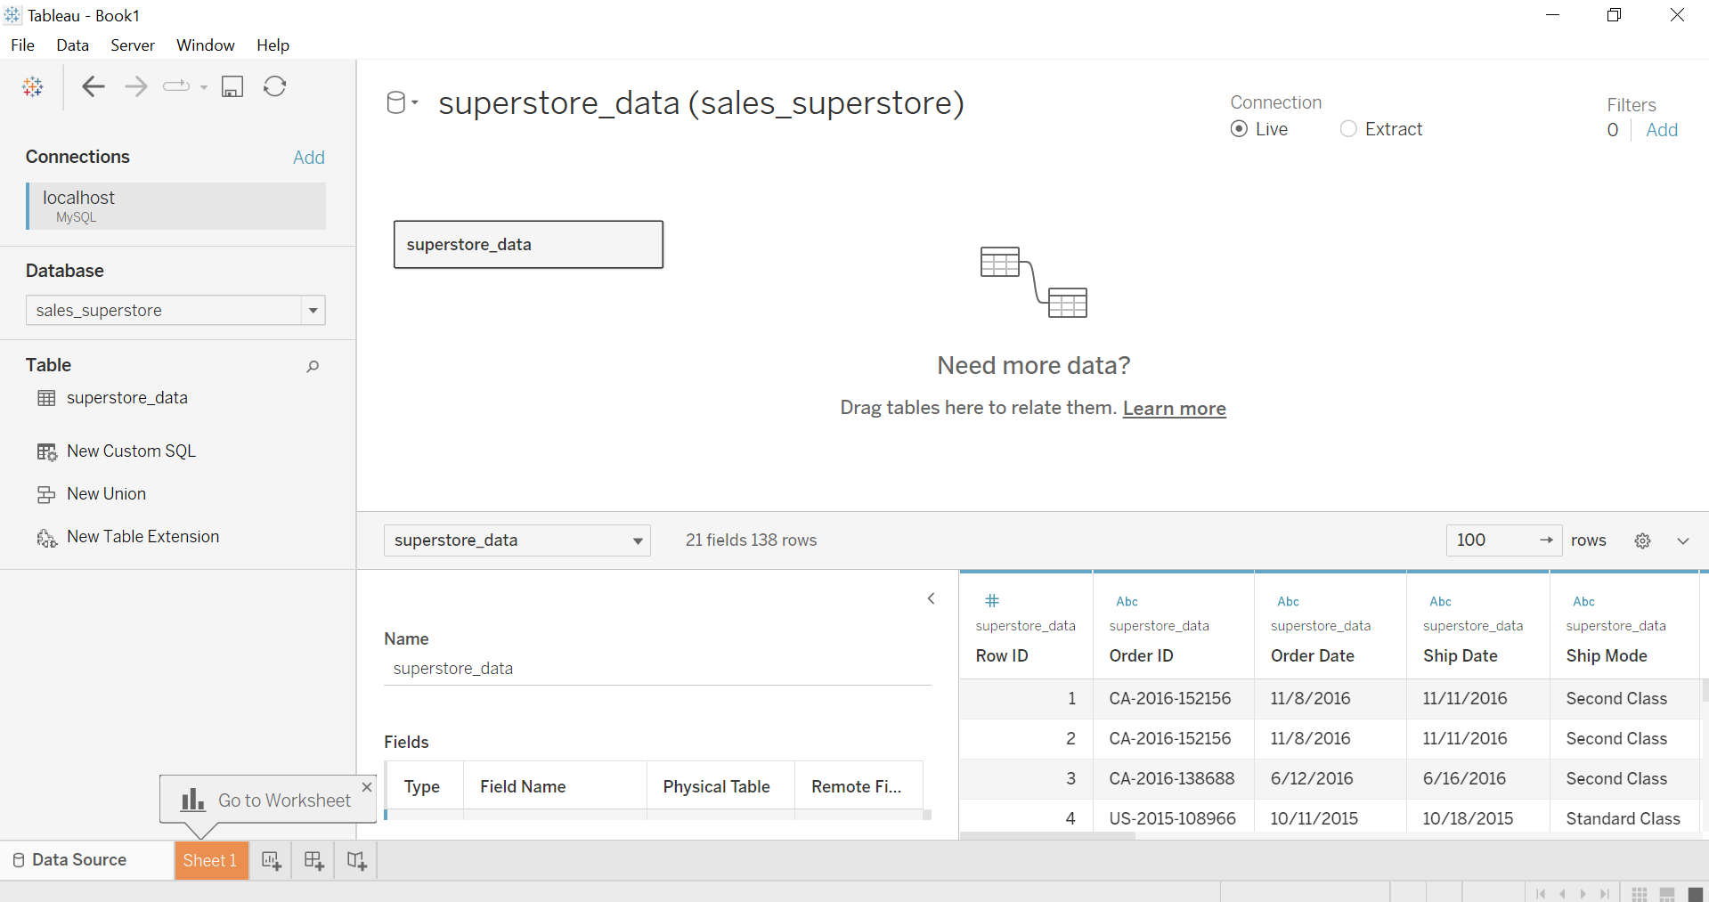

Now, I will start creating the below mentioned charts in order:

Bar Chart

Tree Map

Heat Map

Pie Chart

Horizontal Bar Chart

Bar Chart:

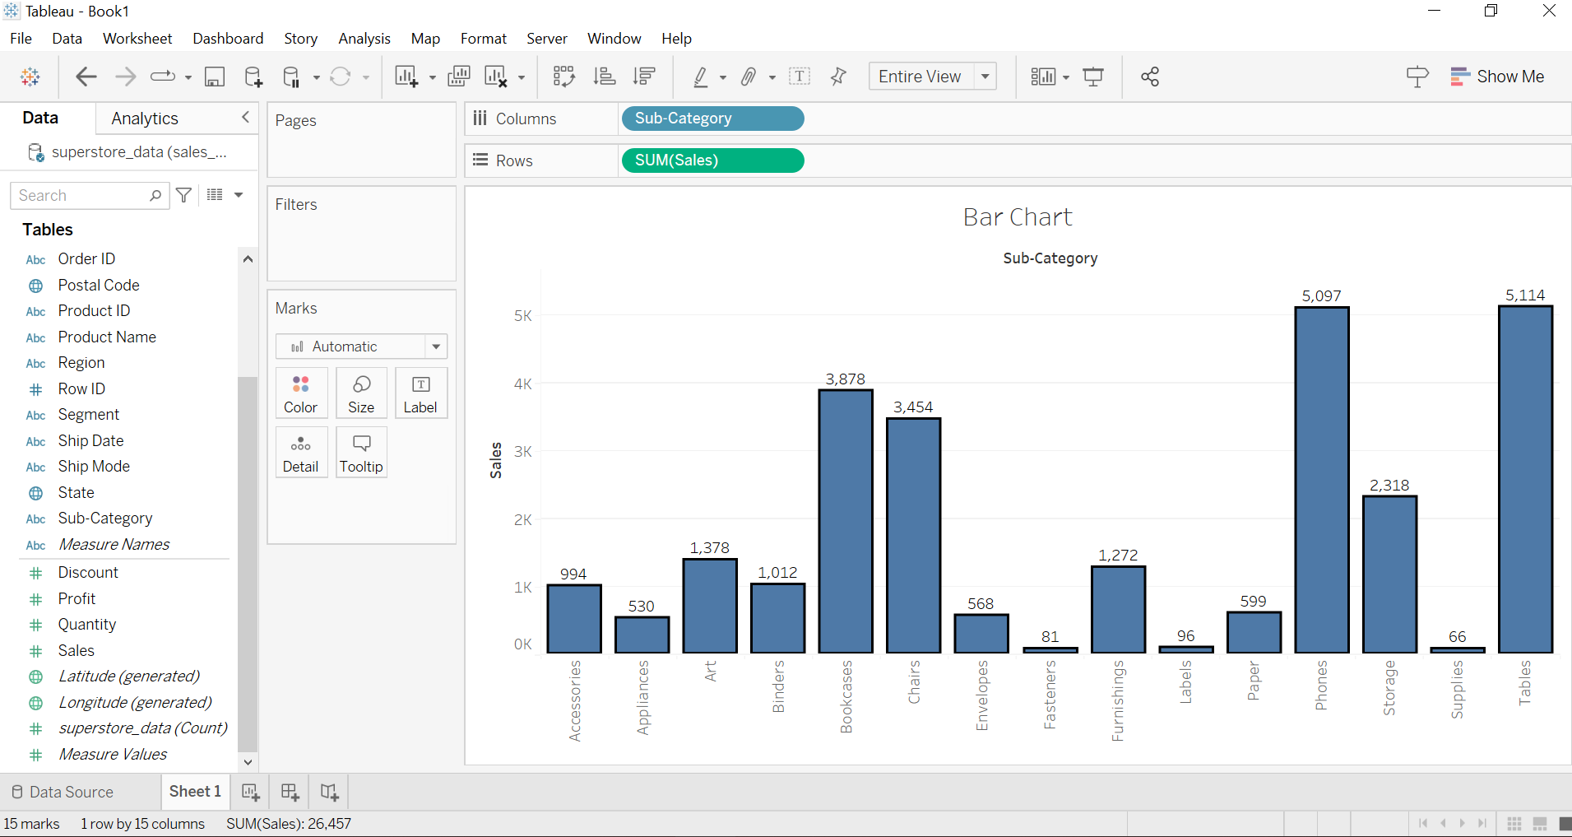

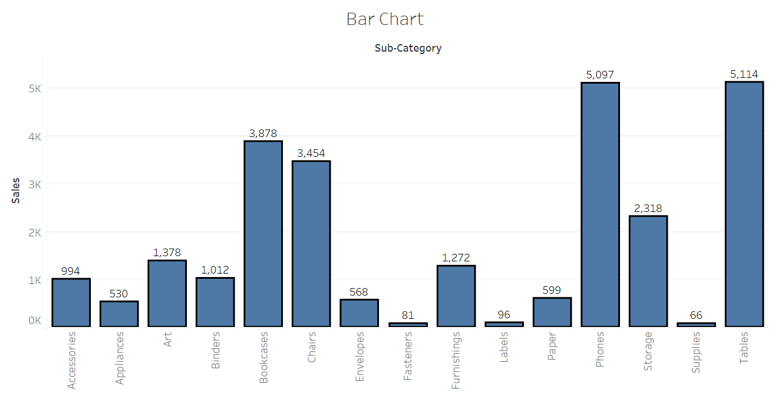

I have created a Bar chart taking sub category in columns and sales in rows. We can analyse from the Bar chart that tables have high sales and supplies have low sales among all other sub categories.

Tree Map:

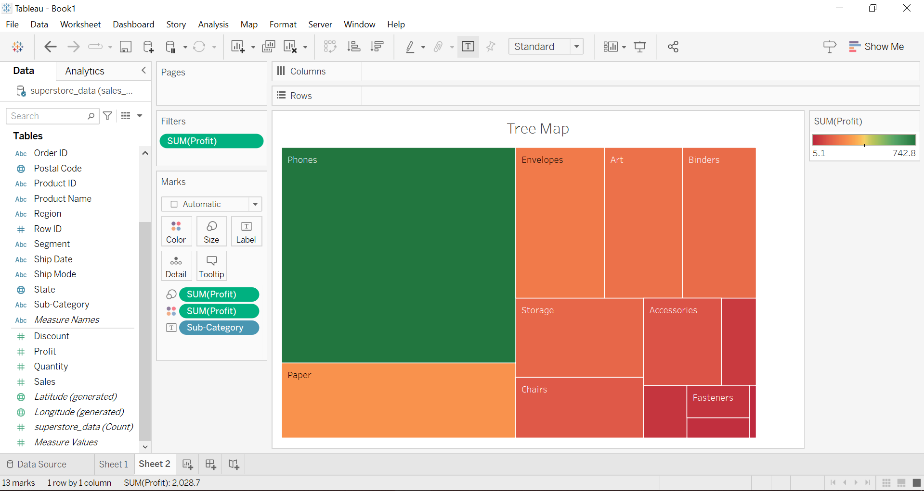

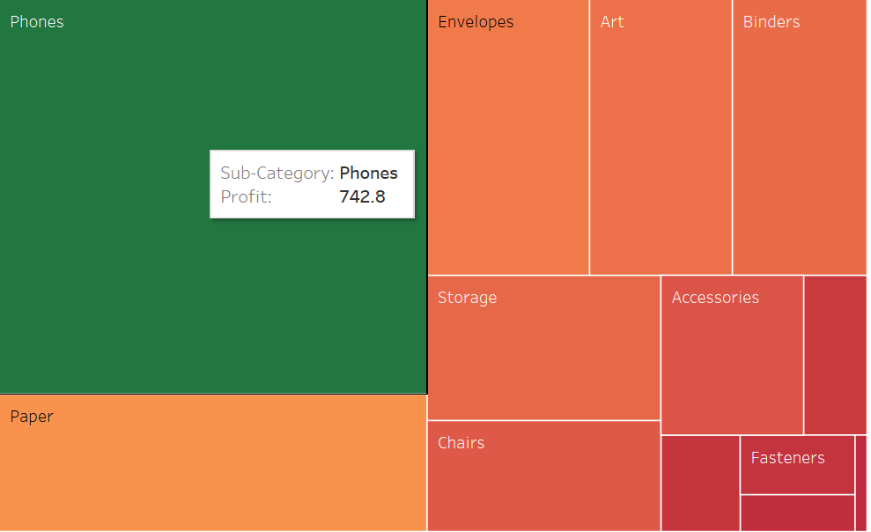

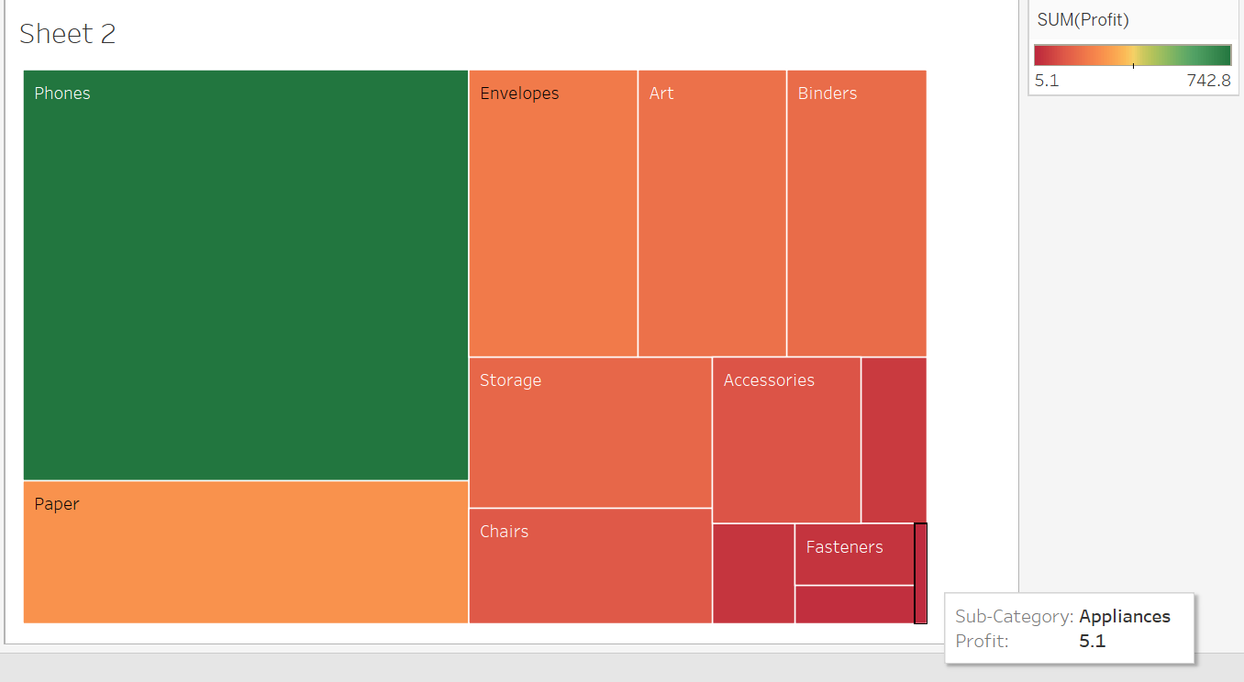

So, I have created a tree map taking sub categories in columns and profit in rows. And from the tree map we can analyse how the colour changed from high profit(green) to low profit(red). The bar beside the chart tells that least profit is 5.1 and highest profit is 742.8.

Heat Map:

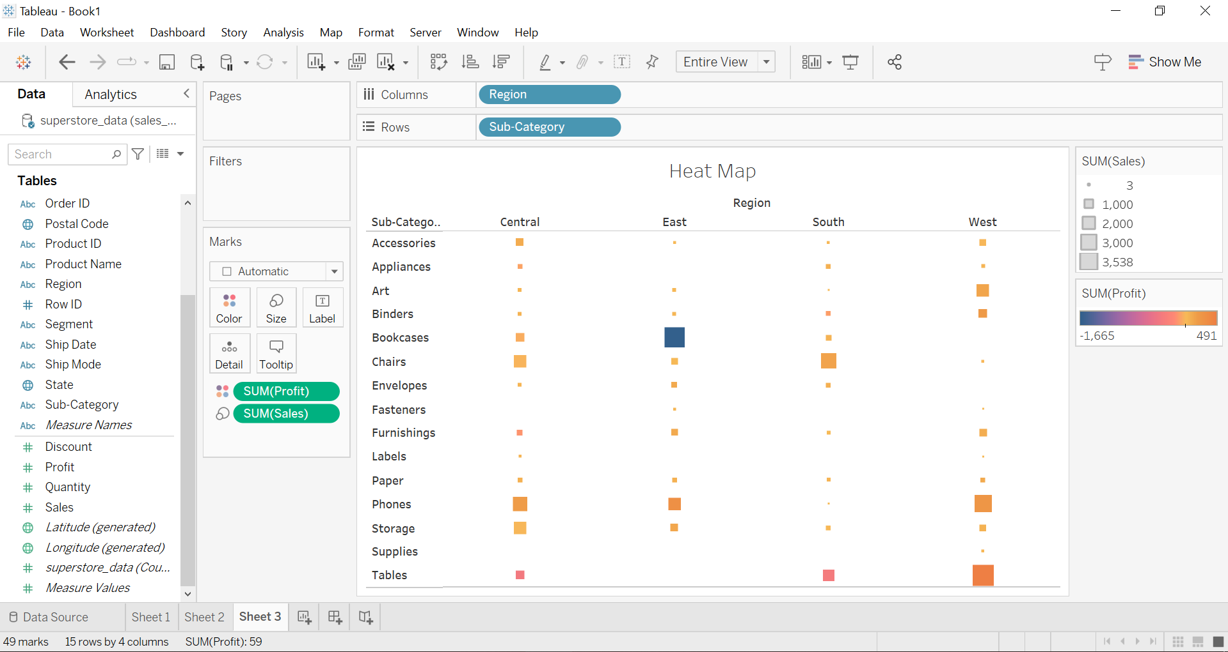

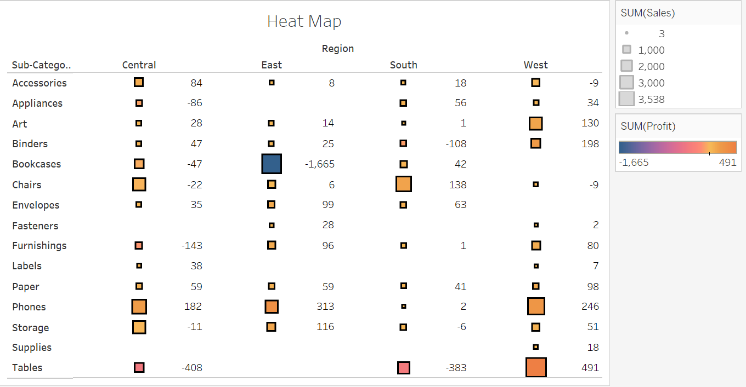

I have created a heat map taking regions as columns and sub categories as rows and adjusting profit for colours and sales for size. So basically, we can take many factors for comparing while using a heat map. We can analyse from above heat map that the larger the size of the box is, the larger are the sales of the subcategory in the region and the lighter(yellow) the colour is, the larger is the profit of the subcategory in the region.

Pie Chart:

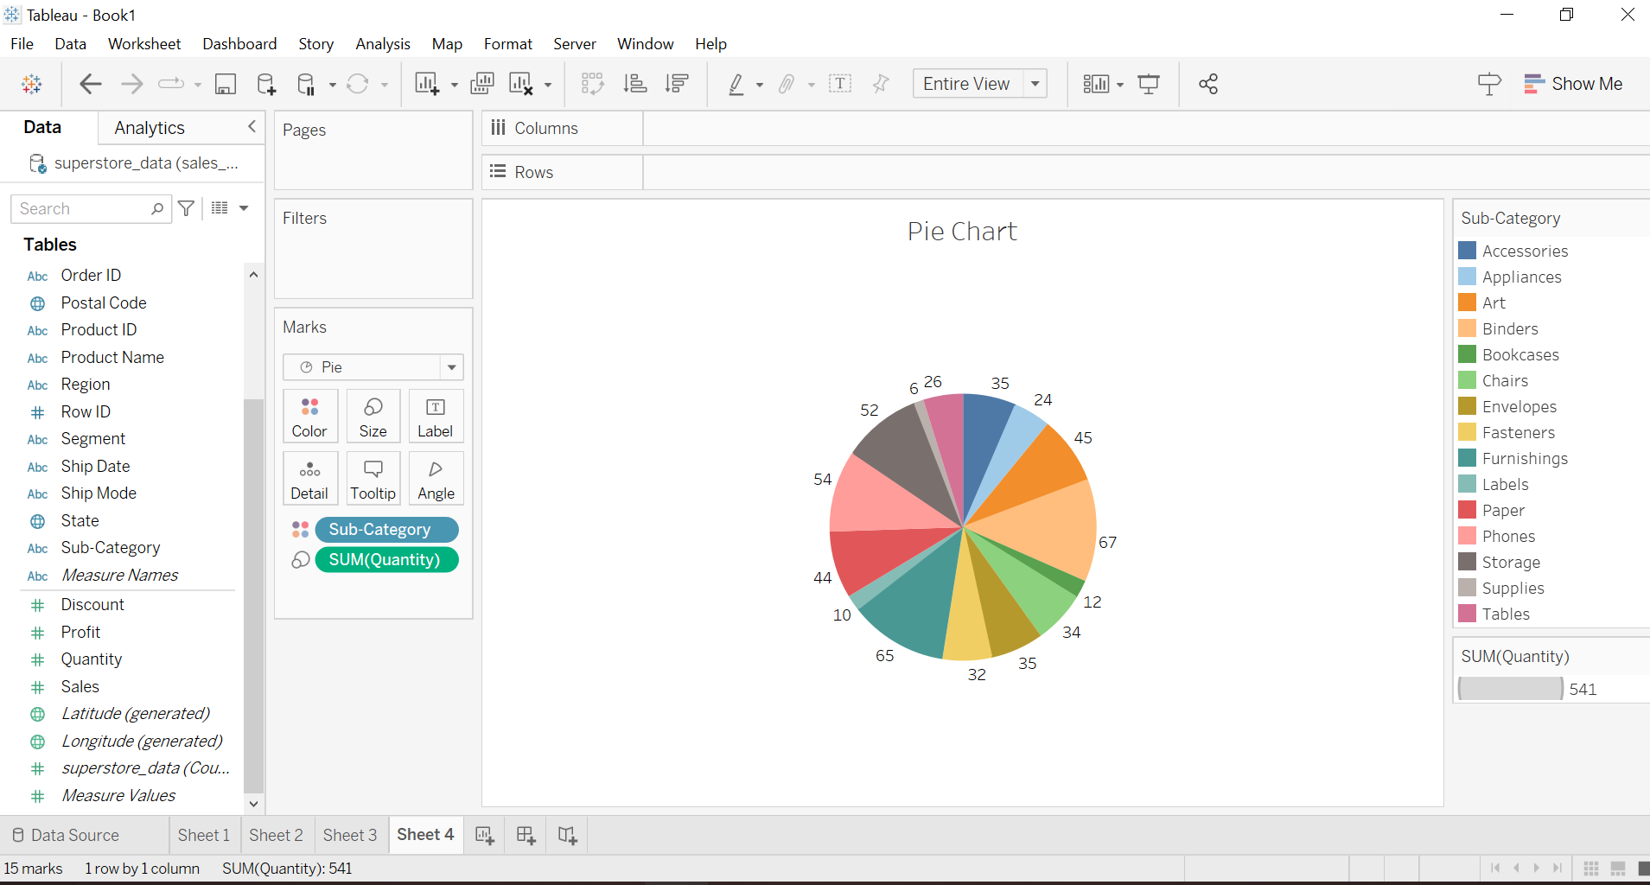

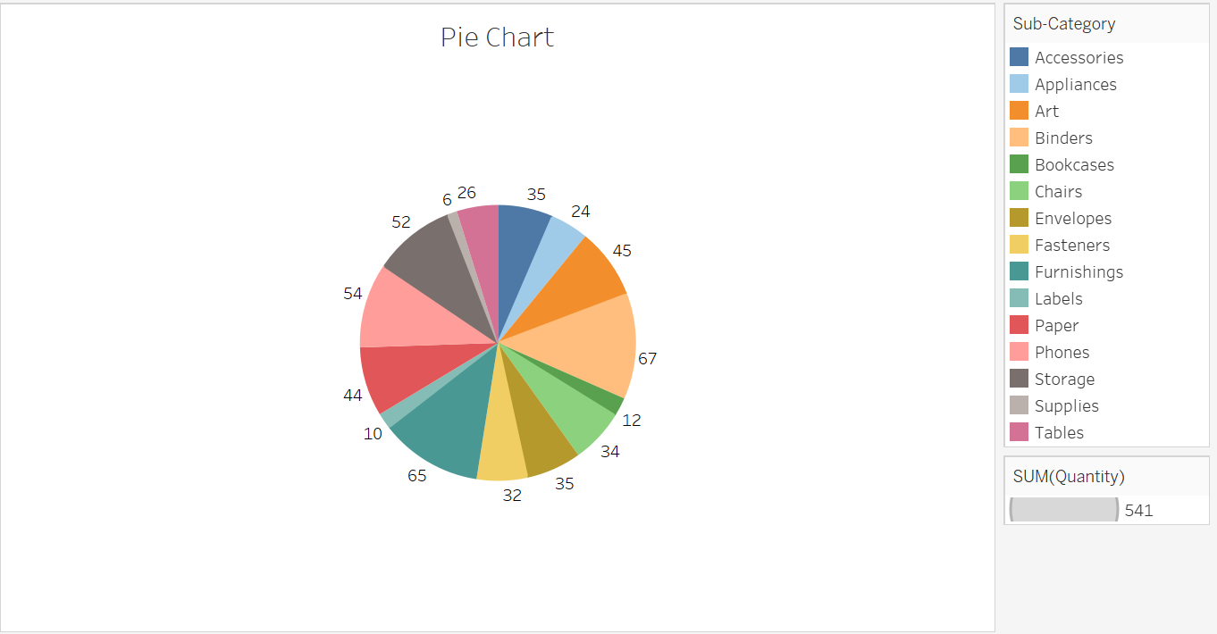

I have created a pie chart taking sub categories in colours and quantity in sizes. From the above pie chart, we can analyse that there is a large quantity of Blinders while there is a least quantity of supplies. And there are 541 things in total.

Horizontal Bar Chart:

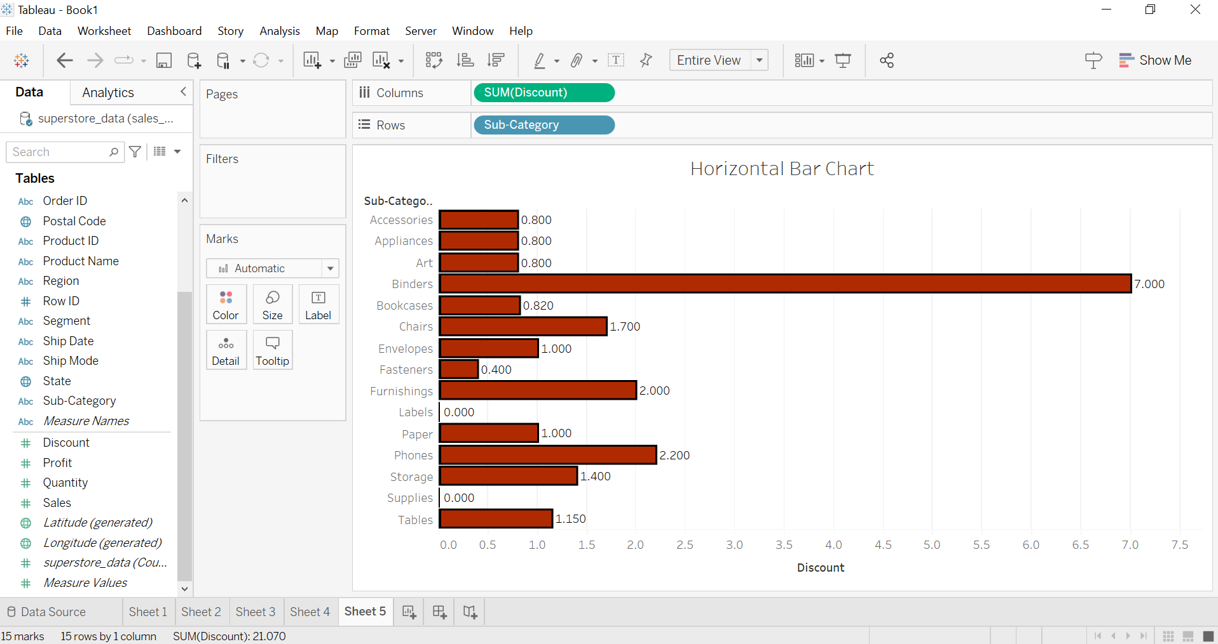

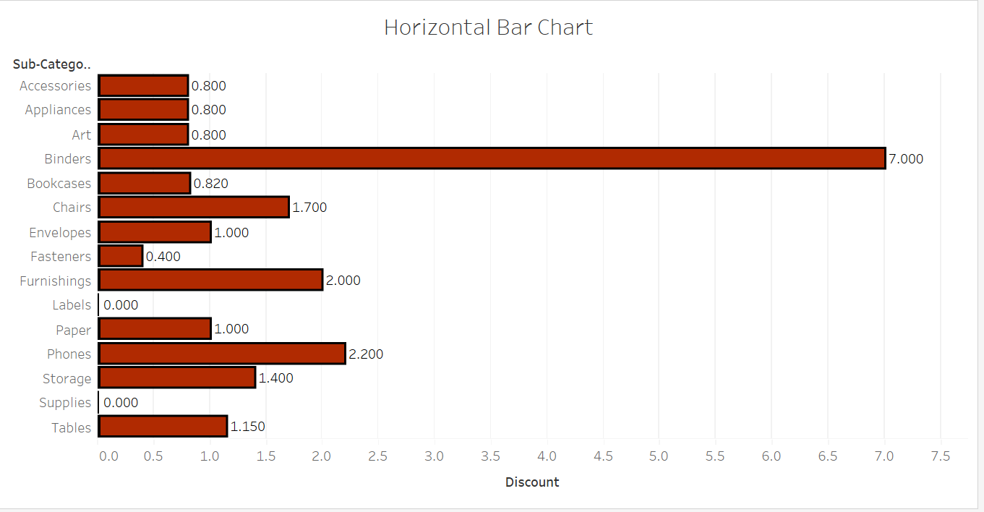

I have created a Horizontal Bar chart taking sub categories in rows and discount in columns. From the above chart, we can analyse that supplies have the least discount rate while blinders have the highest discount rate.